Testing and Evaluation
TC01 - Patient Registration
- Expected (Success): Account is created successfully, a confirmation message is shown, and the user is redirected to the login page.
- Error Case: If the username already exists, an error message is displayed and registration is prevented.
- Status: PASS
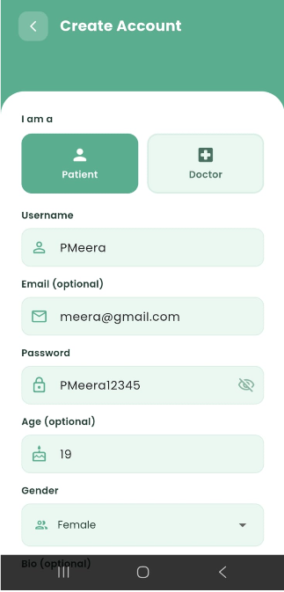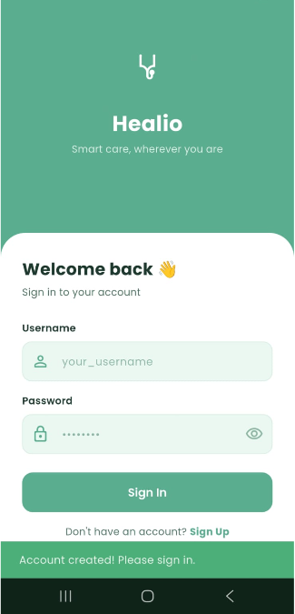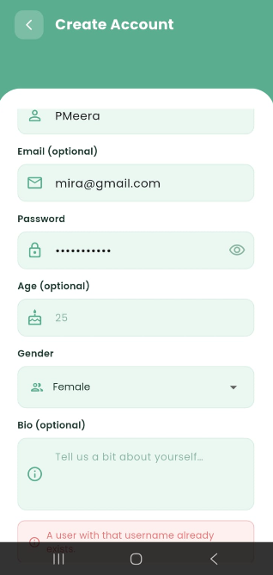

TC02 - Doctor Registration
Expected (Success): Account is created and a message indicates that admin verification is required.
Error Case: Duplicate username shows an error and blocks registration.
Status: PASS
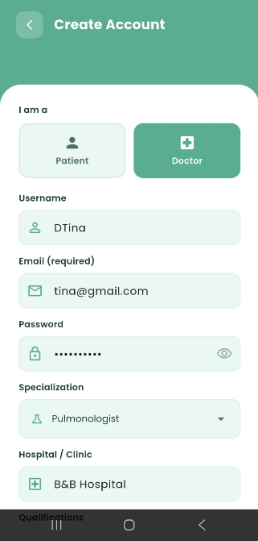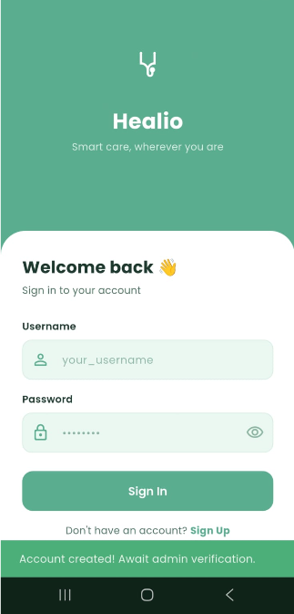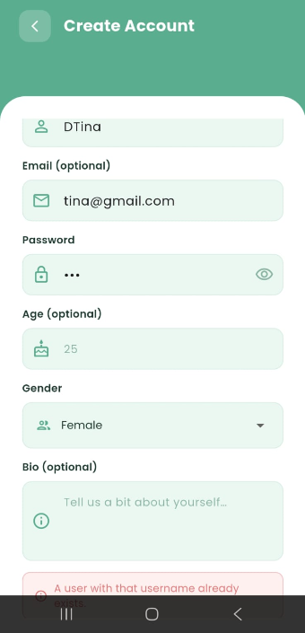

TC03 - User Login
Expected (Success): User logs in successfully and is redirected to the home screen.
Error Case: Invalid credentials display an error message and prevent login.
Status: PASS
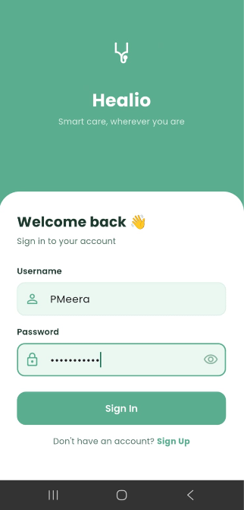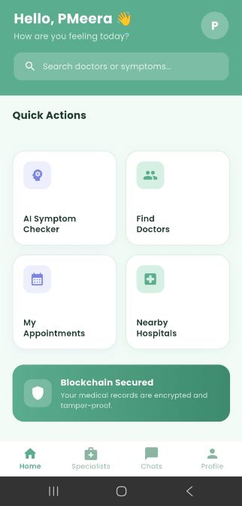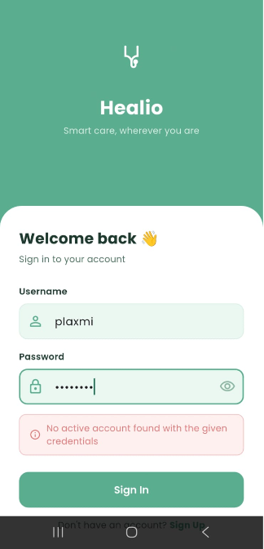

TC04 - AI Symptom Checker
Expected (Success): System analyzes selected symptoms and displays predicted disease, confidence score, precautions, and doctor recommendations along with nearby hospitals.
Status: PASS
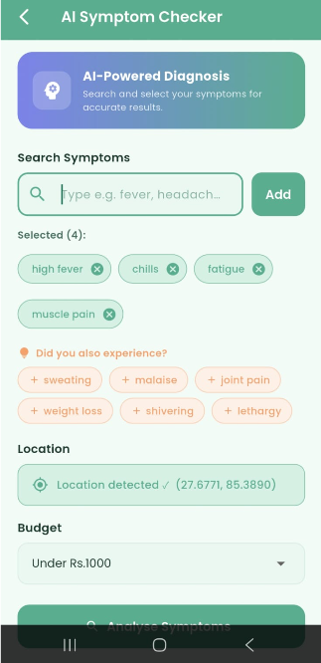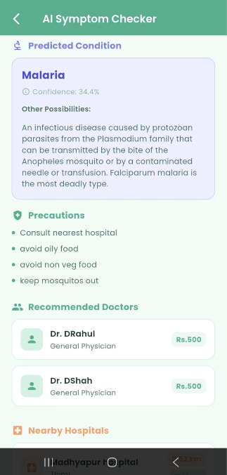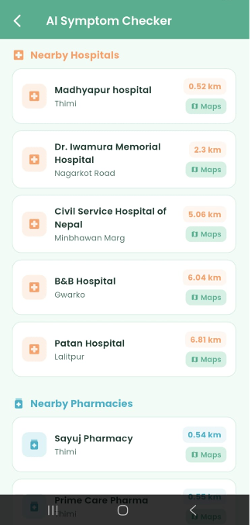

TC05 - Book Appointment
Expected (Success): Appointment is created successfully and a confirmation screen shows doctor’s name, date, time, and QR code for payment.
Status: PASS

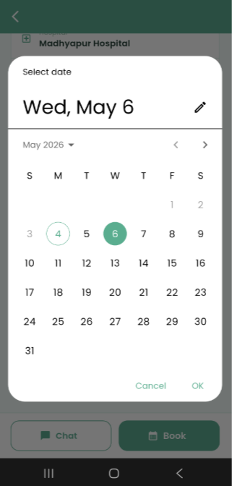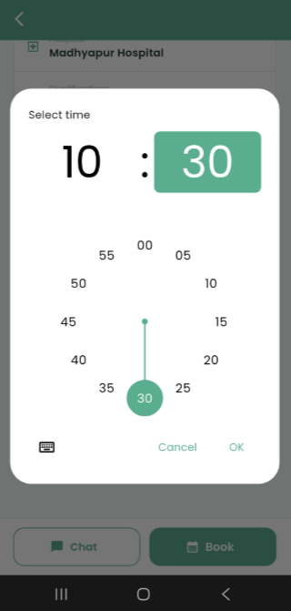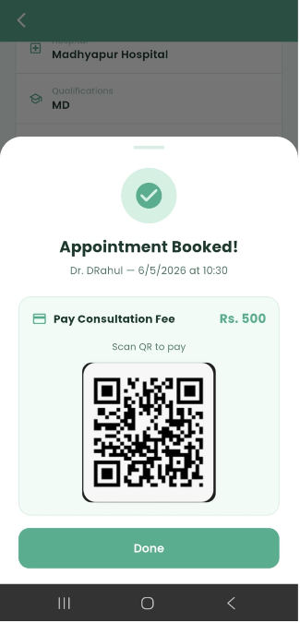

TC06 - View Appointments
Expected (Success): All appointments are displayed with status, date, time, and doctor information.
Status: PASS
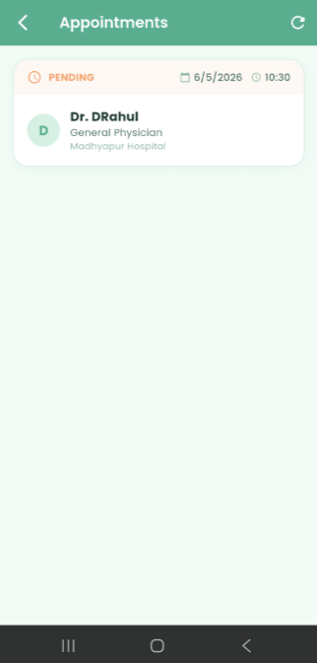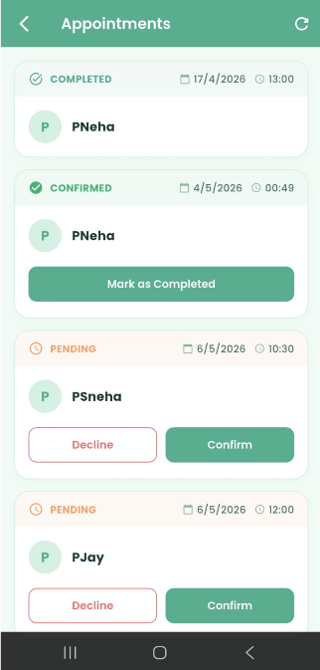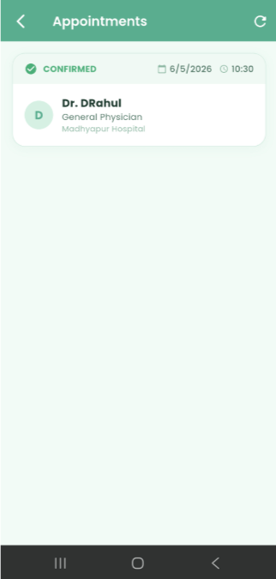

TC07 - Real-time Chat
Messages are sent and received instantly, and the doctor’s online status is visible.
Status: PASS
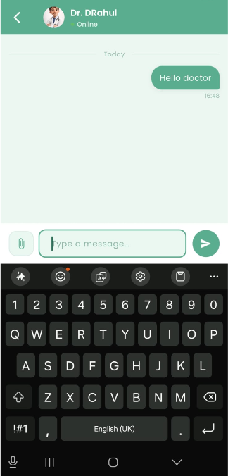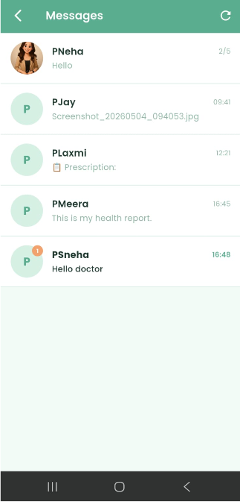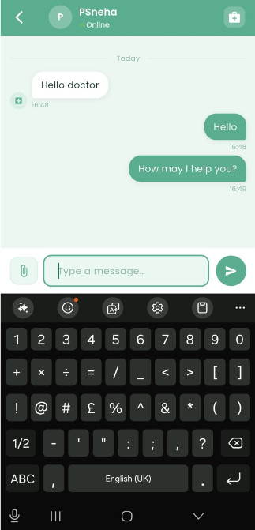

TC08 - Share File in Chat
Expected (Success): Selected file uploads successfully and appears in the chat for both users.
Status: PASS
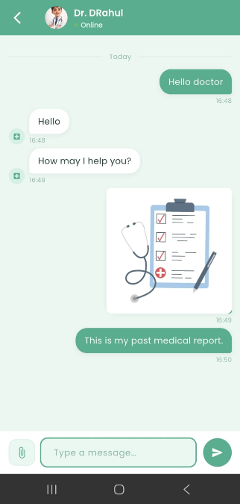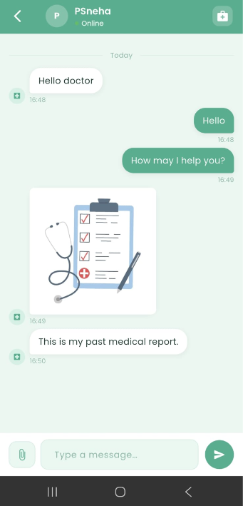

TC09 - Nearby Hospitals and Pharmacies
Expected (Success): Map displays user location and nearby hospitals, with a list sorted by distance and navigation option available.
Status: PASS
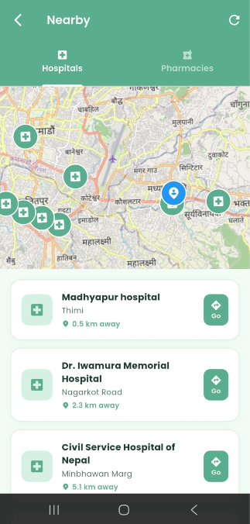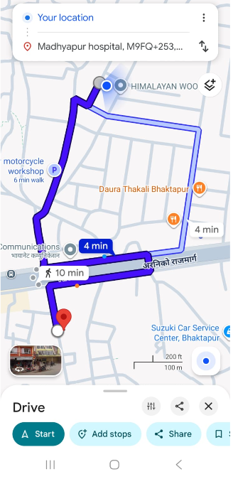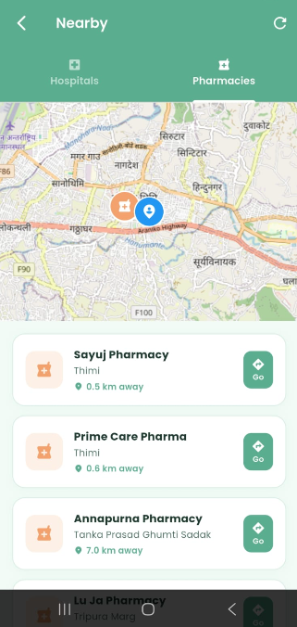

TC10 - Blockchain Verification
Expected (Success): System verifies records and displays confirmation that data is secure and tamper-proof.
Status: PASS
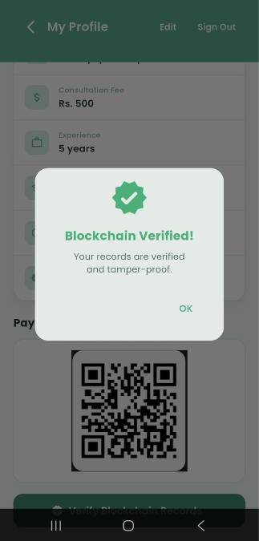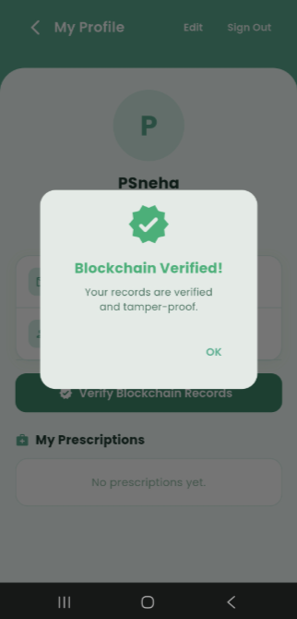

TC11 - Doctor Manages Appointment
Expected (Success): Doctor can update appointment status (Confirmed/Completed), and changes are reflected for the patient.
Status: PASS
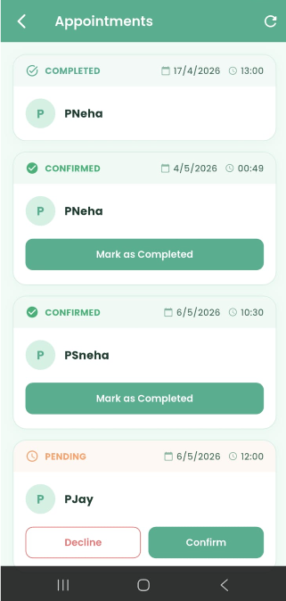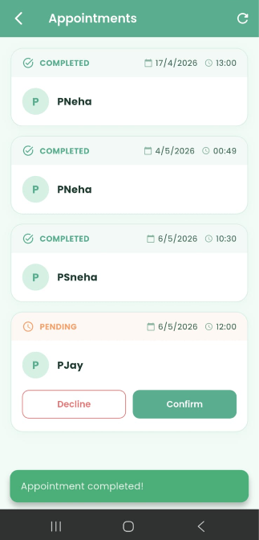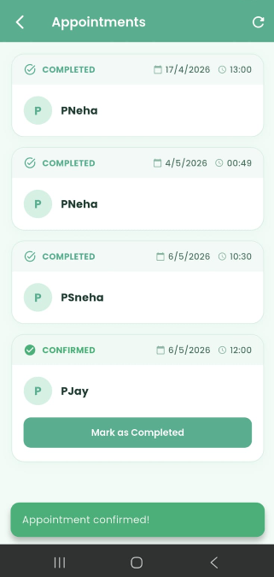

TC12 - Doctor Writes Prescription to Blockchain
Expected (Success): Prescription is saved securely on blockchain and appears in the chat.
Status: PASS
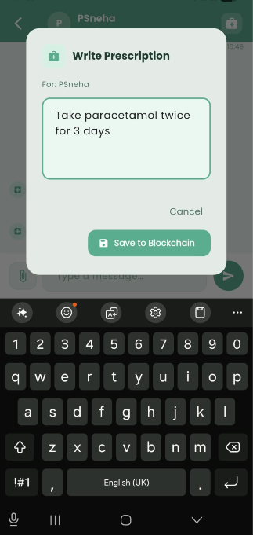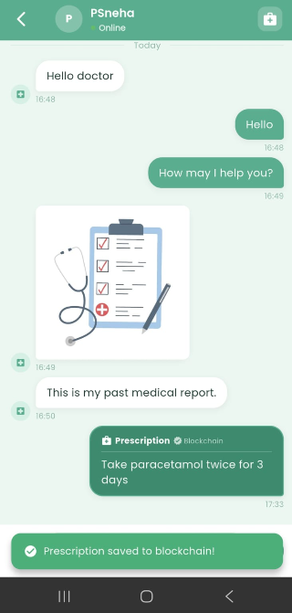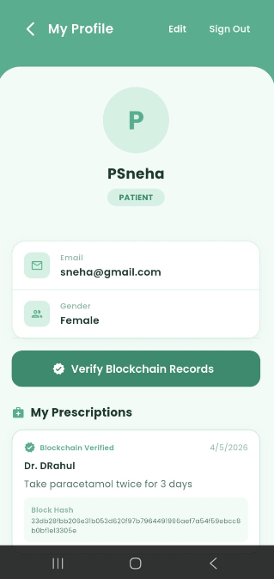

TC13 - Admin Verifies Doctor
Expected (Success): Doctor is marked as verified and becomes visible to patients and verification is securely recorded.
Status: PASS
